Assignment 3 - Structured Types

Student name
Institution of Affiliation
Professor
Date

Assignment 3 - Structured Types
- Write a python function which calculates the product of all integers in a list. Write additional statements that calls this function and passes the list - [3,4,5,6,5.5,10.1234].
- def multiply(numbers):
total = 1
for x in numbers:
total *= x # calculate the products
return total
print(multiply((3,4,5,6,5.5,10.1234))) #calls the function and pass the list
results
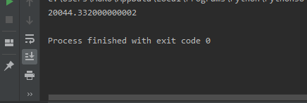

- Create a tuple with the values – informatics, spring, semester, I501, 2018, 63, students and print each value using for loop.
- course = ['informatics', 'spring', 'semester', 'I501', '2018', '63' ]
for index in range(len(course)):
print 'Current course :', course[index]

- l1= ['student','math','skills']
l2 =['student','python','script']
for the given lists, show the value equality, object equality and print id for each of the lists.
# 4
list1 = ['smith', 'john', 'andy'] #List one
list2 = ['kim', 'mary', 'paul'] #list two
if list1 ==list2: # check for equal values
print('true') # Print true if equal
print("List2 :",list2) #print list2
print("List1 :", list1) #print list1
Output
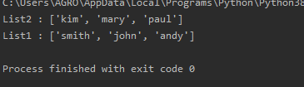

- list1 = ['smith', 'john', 'andy']
list2 = ['kim', 'mary', 'paul']
Write a python program which does the following:
a. add items in list2 to list1
b. Remove mary from list1
c. Insert sam at 5th position
d. Sort the elements of list1 in ascending order

list1 = ['smith', 'john', 'andy'] #List one
list2 = ['kim', 'mary', 'paul'] #list two
for i in list2:
list1.append(i)
list2.insert(4,'Rony') # add item rony to list2
list1.remove('mary') #Remove item mary in list1
list1.insert(5,'sam') #insert item sam in position 5
list1.sort() #sort
print("List2 :",list2) #print list2
print("List1 :", list1) #print list1

output
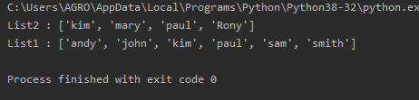

- Write a python program that asks the user to enter a sentence and creates a list of words in that sentence
# asks the user to enter a sentence and creates a list of words in that sentence
string=input('Enter a sentence')
words=list(set(string.split()))#split stings into list
print(words) #output word list
Output
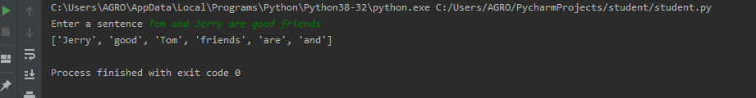

- friends = ('sam','andy','mary','andy','john','andy','mary')
Write a python program which does the following:
a) for the above string calculate the number of times "andy" appears in the tuple
b) change sam with smith
c) print index of john

friends = ('sam','andy','mary','andy','john','andy','mary') # LIST for friends
count=0
for i in friends: #loop
if i=='andy':
count+=1
print('Andy appears',count,'times') # Count appearence of andy
temp=list(friends)
temp[0]='smith' # Change Sam to Smith
friends=tuple(temp)
print(friends)
print(friends.index('john')) # print index of john

Output
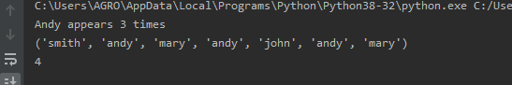

- dict = {'data1':100,'data2':54,'data3':247, 'data4':100,'data5':54,'data6':247}
for the given dictionary, write a program that does the following:
a) print all keys b) print all values c) calculate length
#7
dict = {'v1':100,'v2':54,'v3':247, 'v4':100,'v5':54,'v6':247}
# Print all keys
print('Keys are ',dict.keys())
# Print all value
print('Values are ',dict.values())
# Calculate length
print('Length is ',len(dict))

